IN4340: Case Simulation 3

Promoting food security in Malawi using climate data

A comprehensive, nationwide management information system is being built to harmonise climate, demographic and agricultural data to improve food security in Malawi.

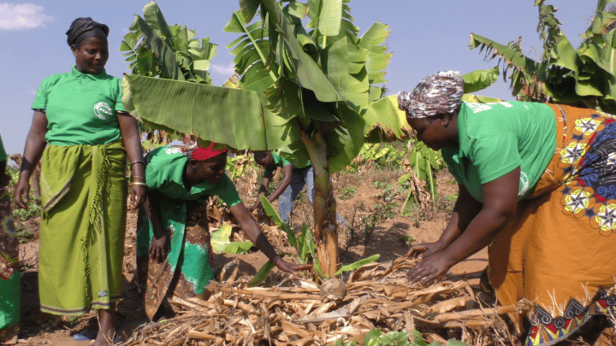Lead farmers monitor crop development at a plantation in rural Malawi.
The economy of Malawi is largely driven by agriculture, which accounts for about 30% of the country’s Gross Domestic Product (GDP) and up to 80% of its exports. As such, most households in the country engage in some form of agricultural activities both for subsistence and commerce. This is reflected in the National Agriculture Policy which stated that “Agriculture remains the mainstay of Malawi’s economy, contributing significantly to employment, economic growth, export earnings, poverty reduction, food security, and nutrition.” The country, therefore, set out to optimize agricultural inputs, processes and production by leveraging data from multiple sources to provide agriculture extension services, guidelines and essential information to farmers, as well as supplying planning data to policymakers and managers nationwide. This initiative is targeted at improving food security and agricultural productivity through sustainable data-supported practices. To achieve this objective, the Ministry of Agriculture (MoA) (http://agriculture.gov.mw) implemented a National Agricultural Management Information System (NAMIS) using the DHIS2 platform.
The NAMIS was developed with the support of a team at the University of Malawi, and builds on the country’s extensive experience gained from over a decade-long use of DHIS2 as a national Health Management Information System (HMIS) covering many health programs. The NAMIS system has also been extended to complement built-in DHIS2 functionalities by using custom applications that provide tailored reporting for M&E purposes and help the government of Malawi to deliver early warnings about weather events to farmers. Using the NAMIS, food situation assessments for individual households are routinely conducted and evaluated alongside projected production estimates of staple foods to facilitate effective food security planning in the country. Data generated in the system has also been utilized to direct resource allocation, improve capacity in small to medium-sized farms and promote local market integration for farmers.

Early warning, planning and action guidance through multi-stream data collection and analysis using DHIS2
The NAMIS receives climate and weather data from a nationwide array of weather stations managed by the MoA. Periodically, the Agricultural Extension Development Officers (AEDOs) collect the readings of the weather stations and enter the data into the NAMIS using specially configured tablet devices running a custom rainfall data collection tool. The same data is also shared with the Department of Climate Change and Meteorological Services (DCCMS) within the Ministry of Natural Resources and Climate Change by means of manual registers submitted monthly. The DCCMS relies on these records, data from other weather stations across the country and satellite data to collect and analyze statistics on rainfall, temperature, humidity and wind dynamics. The data are used to make projections and forecasts, which are shared as reports for specific periods like the 5-day; weekly; and seasonal weather forecasts. The data underlying these reports are shared with the MoA where it is then imported into the NAMIS and used to provide early warnings about weather events such as floods or droughts. The warnings are sent out to the farmers for necessary actions, like irrigation planning to safeguard their crops and maintain productivity levels. The data also helps the government plan special safety interventions like evacuations or large-scale irrigation which are beyond the capacities of individual households.
Malawi is one of Africa’s most susceptible countries to climate change, and agriculture in the country is often adversely affected by climate-related stressors such as droughts, floods, erratic rainfall and dry spells. Between 2018 and 2019, Malawi suffered crippling dry spells and damaging floods in different parts of the country resulting in a 15% decline in food production. These climate events, in addition to other socio-economic factors, are important to food security planning in Malawi, hence the need for reliable data-backed decision support systems. The Ministry of Agriculture (MoA) has developed the National Agriculture Management Information System (NAMIS) to provide a basis for data-backed decision-making. Some of the most prominent capabilities of the NAMIS are providing early warning on relevant weather and climate events and assessment of food security situations both for individual households and the country in general. The three-tiered early warning feature includes the following:
- Weather and climate events
- Household food situation assessment
- Agricultural production estimates
The registry is routinely updated during the bi-weekly rapid household food assessment, a community-based survey conducted by the AEDOs to collect information on staple foods held within each visited household to estimate the household food security status for the next fortnight. Consequently, the AEDOs rank the households based on established food security metrics and provide required advice to the household on the ideal course of action. An aggregate of these indicators collected throughout the country helps the MoA to estimate national food security status. The data, when combined with climate data, food storage information from the National Food Reserve Agency and food production estimates, help the MoA plan for enhanced disaster resilience and preparedness, thereby strengthening food security in the country.

Activity
Imagine to be conducting an action research project on using NAMIS for DHIS2 in Malawi. Local implementers are seeking to improve the system so that it can best inform resource allocation, early warning of emergencies and broader action towards food security. To do so, it is crucial to understand user experience of NAMIS among the MoA staff that uses it.

As a group, reflect on the following points:

- What research questions would you possibly ask on the use of NAMIS at the Ministry of Agriculture? Remember the rules of clarity, feasibility, and relevance of research questions.

- How would you use action to bring understanding of NAMIS user experience? In particular, think of the following:

- What sort of action would be appropriate to answer your question? For example, developing a new extension of NAMIS, or piloting the system in a new context?
- Who would you need to involve in such action? How would you approach relevant stakeholders, and set expectations related to your role on the field?
- What consideration (time; research/action balance…) would you make in setting up your action plan with the relevant stakeholders?

- What sort of challenges would you expect in your proposed action plan?

Prepare a short (2-3 minutes) group presentation on your action research project. Feel free to use any web sources to support your work, in particular:

- DHIS2 Website - https://dhis2.org/
- Malawi Ministry of Agriculture website - http://agriculture.gov.mw
- NAMIS executive summary - https://developmentgateway.org/wp-content/uploads/2020/10/NAMIS_ExecutiveSummary_March19.pdf

